Matthew Ernst
METC143
4.20.2017

Problem statement: design a cable that will support a 60 ton vehicle. The cable is 25 foot long and can have an elastic deformation of no more than 10%.

Introduction: In order to design a cable that will meet the required criteria as described above, I will need to know material information, the required diameter for each material based on their Modulus of Elasticity, and the calculated stress based on the diameter sizes. Stress and diameter will be shown on a separate plot.
Results: Component Elements
Calculated Diameter for each material
To find the minimum diameter required for each material based on their Modulus of Elasticity, it is first important to understand what you are given. First, you are given a load of 60 tons, which is equivalent to 120,000 pounds. The length of the cable is 25 feet, and it has an allowable stretch of 10%. Knowing this, the maximum length this cable can reach is 27.5 feet, which makes the strain equal to 0.1. First, you must calculate the stress of each material by multiplying the Modulus of Elasticity by the strain. You can then use this information to find the CSA (Cross Sectional Area) that will be required for each material by dividing the stress by the load. Finally, now that you know the area, you will be able to find the minimum diameter required. The minimum required diameter for aluminum is 0.39 in, 0.23 in for steel, 0.32 in for copper, and 0.36 in for titanium. Of all the selected diameter sizes, I would choose a ½ in. diameter for aluminum, a ¼ in. diameter for steel, and a 3/8 in. diameter for both copper and titanium.
Stress Calculations
Using the minimum diameter of each material, it is now possible to find the cable stress and the lateral stress generated by each material.
Stress vs Diameter Plot

Fatigue Analysis
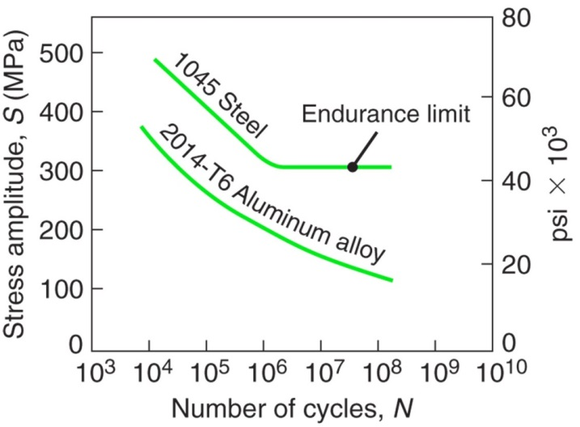
For a selected diameter of 1.75 in, the stress generated for aluminum and steel would be about 49.890 *10^3 psi. For aluminum, this metal would survive approximately 10^4 cycles, but steel would probably survive 10^6 cycles.
Thermal Expansion
The cable has a length of 25 feet, which is 300 inches. Assuming the cable originally starts at standard temperature, or 68 F, this can be used to calculate the change in the length of the cable over a range of different temperatures. Along with the coefficients of thermal expansion, the following information can be generated:
Temperature vs Change in Length for each material:

Conclusions
Each of the aforementioned materials have a specific cable diameter size that will meet the requirements for it to support the 60 ton vehicle. The diameter size picked must not be too big or too small. Aluminum had a minimum diameter size of around 0.39 inches. Anything smaller would not be enough to support the vehicle, so the next biggest size should be picked, which is 0.5 inches. Anything bigger than that would not fit. This goes likewise for all other materials. Steel had a minimum diameter size of about 0.23 inches, so it would be wise to pick a 0.25 inch cable diameter. Copper’s minimum diameter was roughly 0.32 inches and titanium’s was about 0.36 inches, so for both materials, a cable diameter size of 0.375 inches should be used for both materials.
Out of all four materials, I would choose steel. It has the greatest modulus of elasticity out of all the materials, making it the strongest material. It has the second lowest coefficient of thermal expansion among the other materials, making it very stable under a vast range of temperatures. It requires the smallest size diameter that would meet all the aforementioned requirements. This means that steel has the greatest tensile strength of all four materials.

